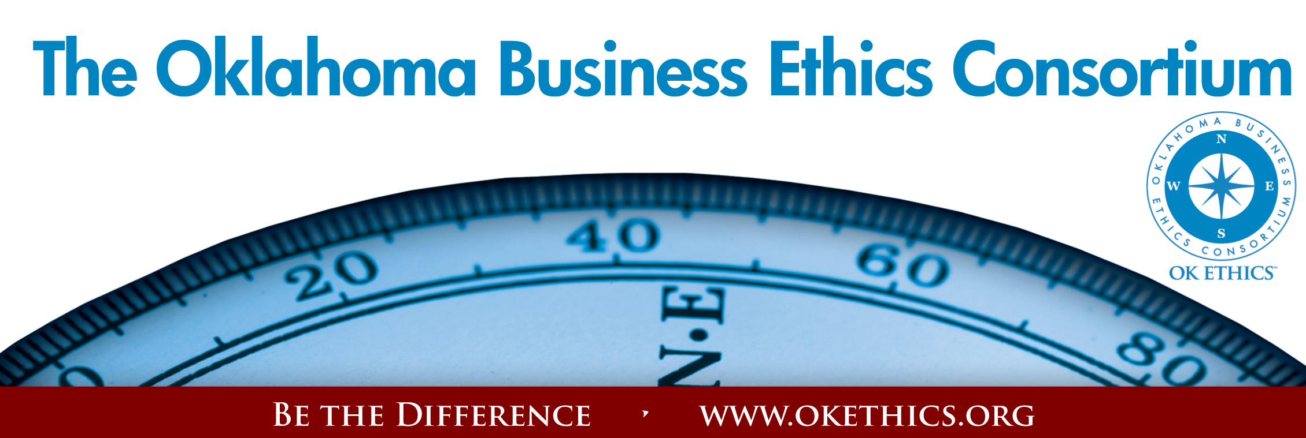
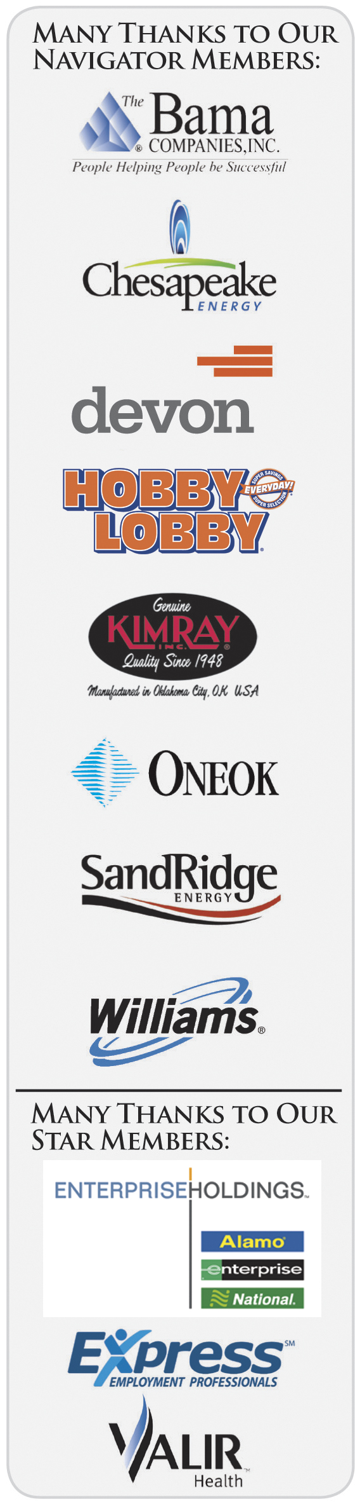
Agenda – March 10, 2010
- Welcome & Kudos
- “Bad Manners = Bad Business” - Carey Sue Vega,
Director, OKC Chapter, International League of Corporate Cotillions
- Introduction: Dr. Carl Hook, CEO, PLICO
- Keynote: “Sorry Works!” - Doug Wojcieszak, Founder,
Sorry Works!
- Upcoming Events – Shannon Warren, Founder, OK Ethics
- Book Signing - $20 per book

REGISTER FOR OK ETHICS COMPASS AWARDS ~ APRIL 20
www.okethics.org or call 889-0498 or 858-2233
Pilot Award Recipient | Keynote Speaker
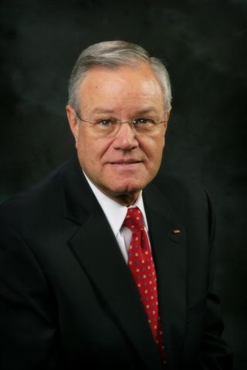 | 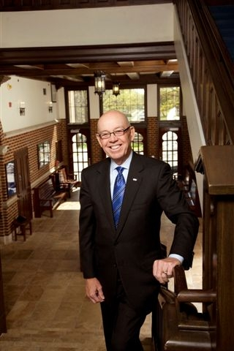
Tom Hill, Chairman of the Board, Kimray, Inc. & Founder,  Character First! Institute | Tom McDaniel, President  Oklahoma City University
CPE CERTIFICATES
It is the responsibility of participants to demonstrate applicability of each program for demonstration of earned CPE credits, to his/her area of practice. OK Ethics makes no guarantees. Also, attendees must be present to accept CPE certificates that will be issued at the conclusion of the program. Please note that we
do not have the manpower capabilities to email these later.
Also, you must be registered on our attendance list
to receive a certificate.

OK Ethics Guiding Principles
Adopted July, 2004*
To ensure that the Consortium fosters positive characteristics of integrity in the successful achievement of its goals, these Guiding Principles were discussed and adopted (with revisions) during a milestone planning session held by Consortium leaders in Stroud on June 18, 2004. These principles were developed based on the Character First Institute's values and philosophies.
I. Responsibility to Self and Others:
- Service:
  - Passion for promoting ethics and integrity
  - Encouraging the promotion of ethical behavior through personal actions and
  - Sharing ideas and resources
  - Responsibility and accountability for fulfilling the mission of the Consortium.
- Collaboration:
  - Achievement of common goals through the promotion of ethical, mutually beneficial relationships
  - Service to the Consortium over promotion of self-interest
  - Cooperation emphasized over competition in promoting ethical business conduct
  - Members collaborate by being constructively engaged in discussions regarding ethics
  - Seeking consensus in interactive discussions regarding ethical matters.
- Respect:
  - Members may become aware of confidential information shared by others in an effort to determine an ethical course of action. We ask members to be sensitive in recognizing and respecting the efforts made toward achieving ethical behavior. In that vein, public disclosure of this information is discouraged.
  - We respect other members and the process by:
    - Exhibiting listening skills and actively listening to discussions
    - Being open to other points of view and outcomes
  - We are an inclusive organization and demonstrate this by welcoming members who are in different stages of learning as applied to ethical behavior.
II. Lead with Integrity
- Dependability:
  - Members are asked to demonstrate their support of this initiative by consistently attending meetings.
- Initiative:
  - Recruiting other members who have demonstrated a desire to promote ethical behavior in their organizations.
  - Recognizing what needs to be done to help promote the Mission of the Consortium and taking action to assist in that effort.
- Honor:
  - Members are asked to honor the Consortium through the practice of integrity and ethical behavior in their business dealings.
  - We express gratefulness to our hosts, sponsors and speakers.
  - Realizing that each of us is in a mode of continual learning, we demonstrate humility, care and compassion when sharing our thoughts and knowledge.
- Courage:
  - Speak the truth with confidence and encourage others to do the same.
JOIN OK ETHICS
- Go to www.okethics.org or call 889-0498
- Do you know someone who has been laid off?
OK Ethics is offering a free Scout membership (value of $75) to any business professional who has been recently impacted by a reduction-in-force. See the website or call 858-2233 for more details.

KUDOS:
This program made possible through the collaborative efforts of:
- The Fountains at Canterbury
- Oklahoma Home Health Care Association
- Oklahoma Medical Quality Award Foundation
- PLICO
- Valir Health
“I always wondered why somebody didn't do something about that.
Then I realized I was somebody.” --Lily Tomlin
OK Ethics is directed and operated entirely by volunteers.
Today’s event was managed by the following individuals:
Registration Team Leaders:
- Greg Byers, Registration Chair – Sinclair Broadcasting
- Mary Kay Huggard, Registration Co-Chair – Principal Technologies

- Mark Neumeister, D.R. Payne & Assoc
- Joe Walker, Grant Thornton

Chief Ambassadors:
- Tere Bettis - Coppermark Bank
- Linda Streun – Ideal Homes
Ambassador Team Members
- Laurie Burt, Jo Hines, and James Paul of Ideal Homes
- Beau Reed and Brent Martens with Accounting Principals
- Diana Wall & Renee Kissler with Accel Financial Staffing
- Steven Menzel with Character First! Institute

Agendas & Handouts: Linda Manaugh, Metro Technology Centers
CPE Certificates: Edith Steele, Retired (Oklahoma Accountancy Board)
Logistics Chairperson: Jamie Potter, Eide Bailly
Name Tags: Lisa Giles & Jamie Potter – Eide Bailly
Power Point Presentations: Connie Storey - Maximum Multi Media Creations
Member Care Coordinator: Deborah Gavula, OK Ethics
Join our team - Contact our leadership
  - Programs: Shannon Warren, Founder, OK Ethics warrenokla@cox.net or 858-2233
  - Membership & Recruiting: Shannon Hiebert, Vice President of Human Resources,
Enterprise Rent-A-Car; Shannon.Hiebert@erac.com or call 330-9191
  - Public Relations: Kellian Schneider, Owner, FullForce Branding & Marketing; kellian@fullforcebusiness.com
  - Ambassador Co-Chairs: Tere Bettis, Vice President of Human Resources, Coppermark Bank, TBettis@coppermarkbank.com or Linda Streun, Director of Human Resources,
Ideal Homes, lindastreun@ideal-homes.com
  - Registration: Mary Kay Huggard, Principal Technologies, marykay@principaltechnologies.com or call .858.8800 x 105

Welcome Special Guests:
- Metro Technology Centers – Health Careers Center
- Oklahoma Christian – Professor Don Hull’s Ethics Class
- Oklahoma County DA’s Office
- PLICO
- University of Central Oklahoma – Advisor Dr. Katherene Terrell
General Disclaimer: Members of the Oklahoma Business Ethics Consortium frequently share information concerning
various issues and developments that may have legal implications. The discussions, commentary, and handouts at
Consortium meetings or presentations to other organizations are for general informational purposes only. They cover
only some aspects of the subject topic, and do not constitute a complete legal analysis of the topic or how it might apply to
any particular set of facts. Before taking any action based on information presented during a Consortium event, participants
are encouraged to consult a qualified attorney. The observations and comments of presenters at Consortium meetings and
networking are the views and opinions of the presenter and do not constitute the opinion or policies of the Consortium or
any of its members. Presenters are respectfully requested to avoid profanity, preaching, politics and self-promotion
during their lectures.

UPCOMING EVENTS

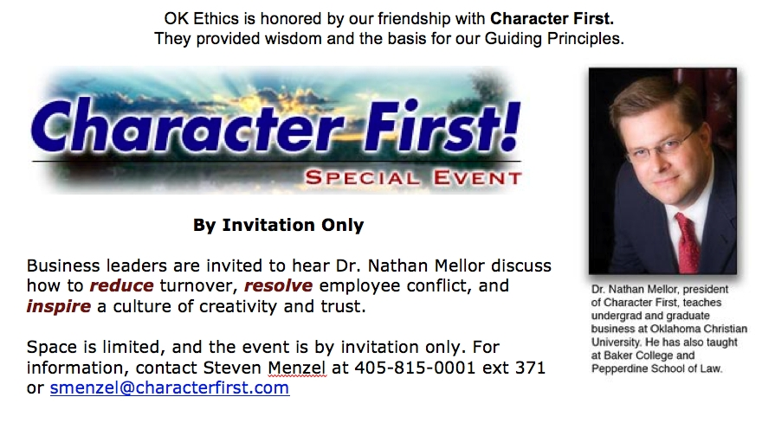

OKC EVENTS
Reserved tables with signage:
$350 to $600*
*Pricing depends on size and
type of organization
$45 per person (Open seating)
See website for details and to register: www.okethics.org

OK ETHICS FIFTH ANNUAL COMPASS AWARDS
APRIL 20, 2010 – 11:30 to 1:15
Jim Thorpe Museum & Oklahoma Sports Hall of Fame, Oklahoma City

KEYNOTE SPEAKER:
TOM MCDANIEL,
PRESIDENT, OKLAHOMA CITY UNIVERSITY

Join us in recognizing companies that promote Oklahoma values of integrity at work.

Also, OK Ethics is proud to present our first executive award to our humble friend,
Tom Hill, Chairman of the Board, Kimray, Inc. and Founder of the Character First Institute.

TULSA EVENTS
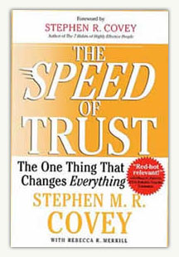
Thursday, March 25
“The Speed of Trust” presented by William Siems,
Certified Covey Trainer with Boeing
Note that OK Ethics members may attend any meeting at a discounted rate.

Thursday, May 27
"Management and Ethics in a Web 2.0 World & Beyond"
presented by Asher Adelman. Founder of eBossWatch.com
The changes brought on by the internet revolution continue to redefine many aspects of our lives, both on the job and at home. The introduction of Web 2.0 technologies marks the beginning of a new phase in the evolution of the workplace that will have broad implications on how managers interact with their employees. Asher Adelman, a great workplace entrepreneur, will share some of these major trends and will discuss how blogs, social networking, and even Google will impact ethical dilemmas, define workplace relations, and alter the boss-employee relationship. His presentation will examine the threats that companies will encounter if they fail to recognize and adjust to these seismic changes.
Asher will also explore innovative workplace branding strategies that will help companies and managers prepare for these impending changes, gain a competitive advantage in their markets, and ensure the loyalty of their employees, customers, and shareholders.

